A Digital Single Market for content: “win-win”, or unintended consequences?

The European Commission has a vision for a European Digital Single Market (DSM) which should be welcomed. However, the reality is that it may not be the “win-win” that has been described.
The ACT – representing the leading producers and distributors of audiovisual content on all platforms in 37 European markets – is naturally supportive of any measures which would result in Europeans legally consuming more of our content, thereby fuelling the virtuous circle of revenues being reinvested in content. We have enthusiastically embraced the many opportunities offered by online distribution: streamed, simulcast, on-demand, OTT, download and play, or catch-up. And we continue to innovate, with companies exploring possible ‘portability’ models allowing subscribers to access content while abroad for limited periods of time.
However, there is an important balancing exercise between the political goal of a DSM, and the public interest in maximising content investment and cultural diversity in Europe –as without the content there is nothing to access across borders at all.
High quality, compelling, European programmes and films are not made on assembly lines like cars, which can be bought and sold regardless of language and culture; instead their production and distribution involves a complex chain of creative decision-making and financial risk in multi-cultural national markets, in a rapidly evolving digital environment.
In the Digital Single Market Strategy, adopted on 6 May 20015, the Commission has identified exclusive territorial licensing for audiovisual content as an impediment to achieving its goals. But will reform here lead to the intuitive win-win scenario that has been described? Our concern is that such measures may in fact produce, unintentionally, a market which is neither in the interests of consumers nor of business.
Major risks for consumers, culture and content investment
Contrary to the Commission’s intentions the elimination or erosion of territorial licensing runs a severe risk of significantly impacting consumer choice, cultural and linguistic diversity and European content investment, undermining the purpose of the initiative which is to broaden access to content. Neither free nor pay online content services, whether from broadcasters or other digital content platforms, will be able to offer content to specific national EU markets: instead, they will be forced to offer their content across an EU market of 500m people.

The unintended consequences of this are likely to be as follows.

- Faced with a series of lower-fee non-exclusive pan-EU deals with a host of national platforms, rights owners to high-value content (sport, films, high-end drama and entertainment) will either sell rights on a pan-EU basis, which smaller national platforms will be unable to pay or withhold content from online distribution until exclusive national windows have expired across the EU (resulting in less content being available online in Europe).

- If rights move to a pan-EU model they are unlikely to be acquired by local domestic operators. Instead the main beneficiaries will be larger content aggregators who offer content in the main European languages, particularly English. This helps explain why the Commission’s proposals are supported by Google and other technology companies. There is a real risk that smaller markets and less-widely spoken languages will be marginalised, leading to a reduction in consumer choice online as their consumers are serviced increasingly by pan-EU international platforms. National online offerings would be impoverished, only being able to secure content rights with no wider international appeal – digital innovation will decline as online rights become harder to secure.

- As rights are increasingly sold to pan-EU platforms for pan-EU distribution, multi-territory funding for European production will decline. This will mean fewer European productions and a greater market share for large-scale, global content produced outside of the EU.

At risk: EU drama production. As TV production values have risen to cinematic quality, broadcasters have sought to spread the risk via either co-productions or pre-sales in different EU markets. Pan-EU distribution would make such European productions very difficult to finance, as the pre-finance market relies on a broadcaster being able to secure exclusivity to distribute in their home market. ITV Studios’ Titanic illustrates the dual role of presales and co-funding in financing content: it was co-funded by, and presold to ITV Studios and 7 other European broadcasters (see annex).

At risk: compelling online content services. Broadcasters are able to offer their viewers a full range of programmes through national online catch-up services. If pan-EU distribution becomes compulsory then premium content, such as high-end drama and sports rights, is likely to be withdrawn from these services in order to preserve revenues from broadcast distribution in other European markets.

At risk: news and local programming. News and local programming is expensive to produce and is financed thanks to the return that broadcasters get from high-value content. In a scenario where only larger content aggregators would be able to acquire rights to high-value content, the ability for local broadcasters to invest in news and local programming will be seriously affected.

At risk: EU-wide availability of football. Currently European football leagues licence their rights in their home country and also across the EU, at different prices which reflects different levels of demand: the result is the widespread availability of matches across the EU. De facto pan-EU distribution will undermine this model with, for example, national platforms securing pan-EU distribution rights in order to maintain exclusivity.

We urge the Member States to model carefully, together with the sector and taking into account existing EC studies, the possible structural consequences of any regulatory-driven shift away from current models of licensing of content.

16/06/2015

ACT member companies
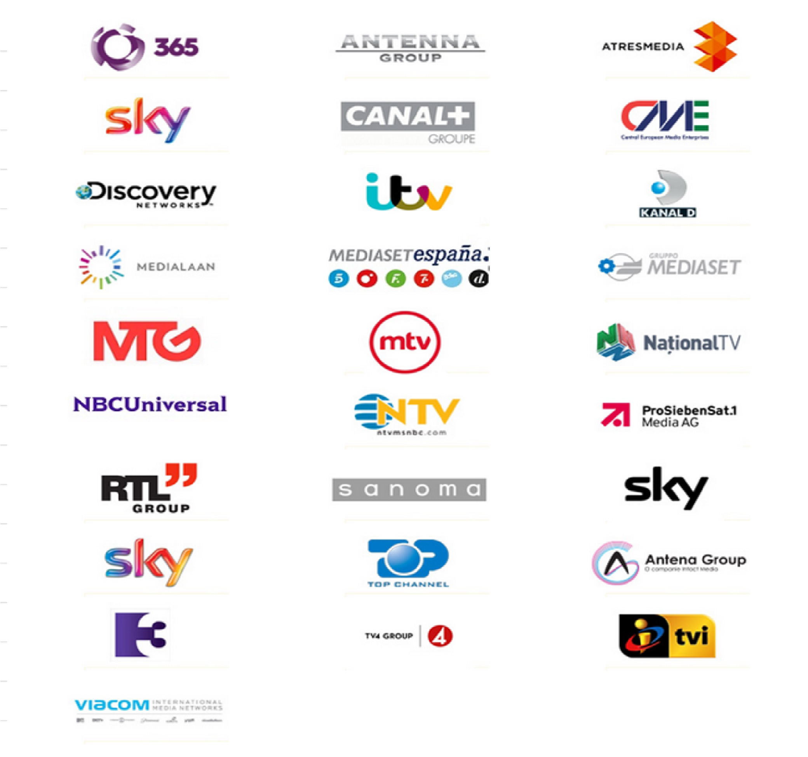

Annex

